Textbook Questions: Chapter 11 INDUSTRY Due _______________________

Key Issue One (p. 384)
- What was the hearth of the IR?
- What were cottage industries?
- What was the catalyst of the IR?
- What invention was most important?
- Why?
- Why is the term IR misleading?
- What 5 industries were impacted the most?
- Explain how for each?
- What previous fuels were used?
- What 3 fossil fuels were part of the IR?
- Explain the origin of each?
- List the 3 main industrial regions in the world.
- Explain each.
- Using the map (11-5,11-6, 11-7) map the industrial regions & annotate each—use maps below.

Key Issue Two (p. 388)
- How does situation impact location?
- How does site impact location?
- Why is proximity to inputs important?
- What is proximity to markets important?
- What are mineral important to industry?
- What are metal important to industry?
- What is the diff b/t ferrous and non-ferrous alloys?
- What is a bulk reducing industry?
- Describe in detail the 5 ways copper is bulk reducing?
- How is location impacted in the copper industry?
- What is a bulk gaining industry?
- Give an example.
- Explain how this is bulk gaining.
- Where do single market manufactures locate?
- Why?
- Explain with YKK.
- Explain with auto manufactures.
- Where do perishable product companies locate?
- Explain IN DETAIL the distribution of auto companies and why they are there.
- Compare 11-16 and 11-17—how have steel mills changed locations—provide details
- Explain how steel production has changed in the US from the 1800s to late 1900s IN DETAIL!!
- How has steel production changed b/t developing and developed countries over time?
- Who is the largest producer of steel?
- What are the 4 main types of transport?
- How does distance impact cost?
- Explain the details of using each of the four.
- What is a break of bulk point?
- How has containerization impacted industry?
- How is cost impacted?
- Why?
- What is just in time delivery?
- How does capital impact location?
- Why is capital important?
- What are the factors when considering land for industry?
- Explain the distribution of clothing production in a min of 120 words.
- Using figure 11-30, how does the cost differ b/t a hoodie made in the US & one in Asia?

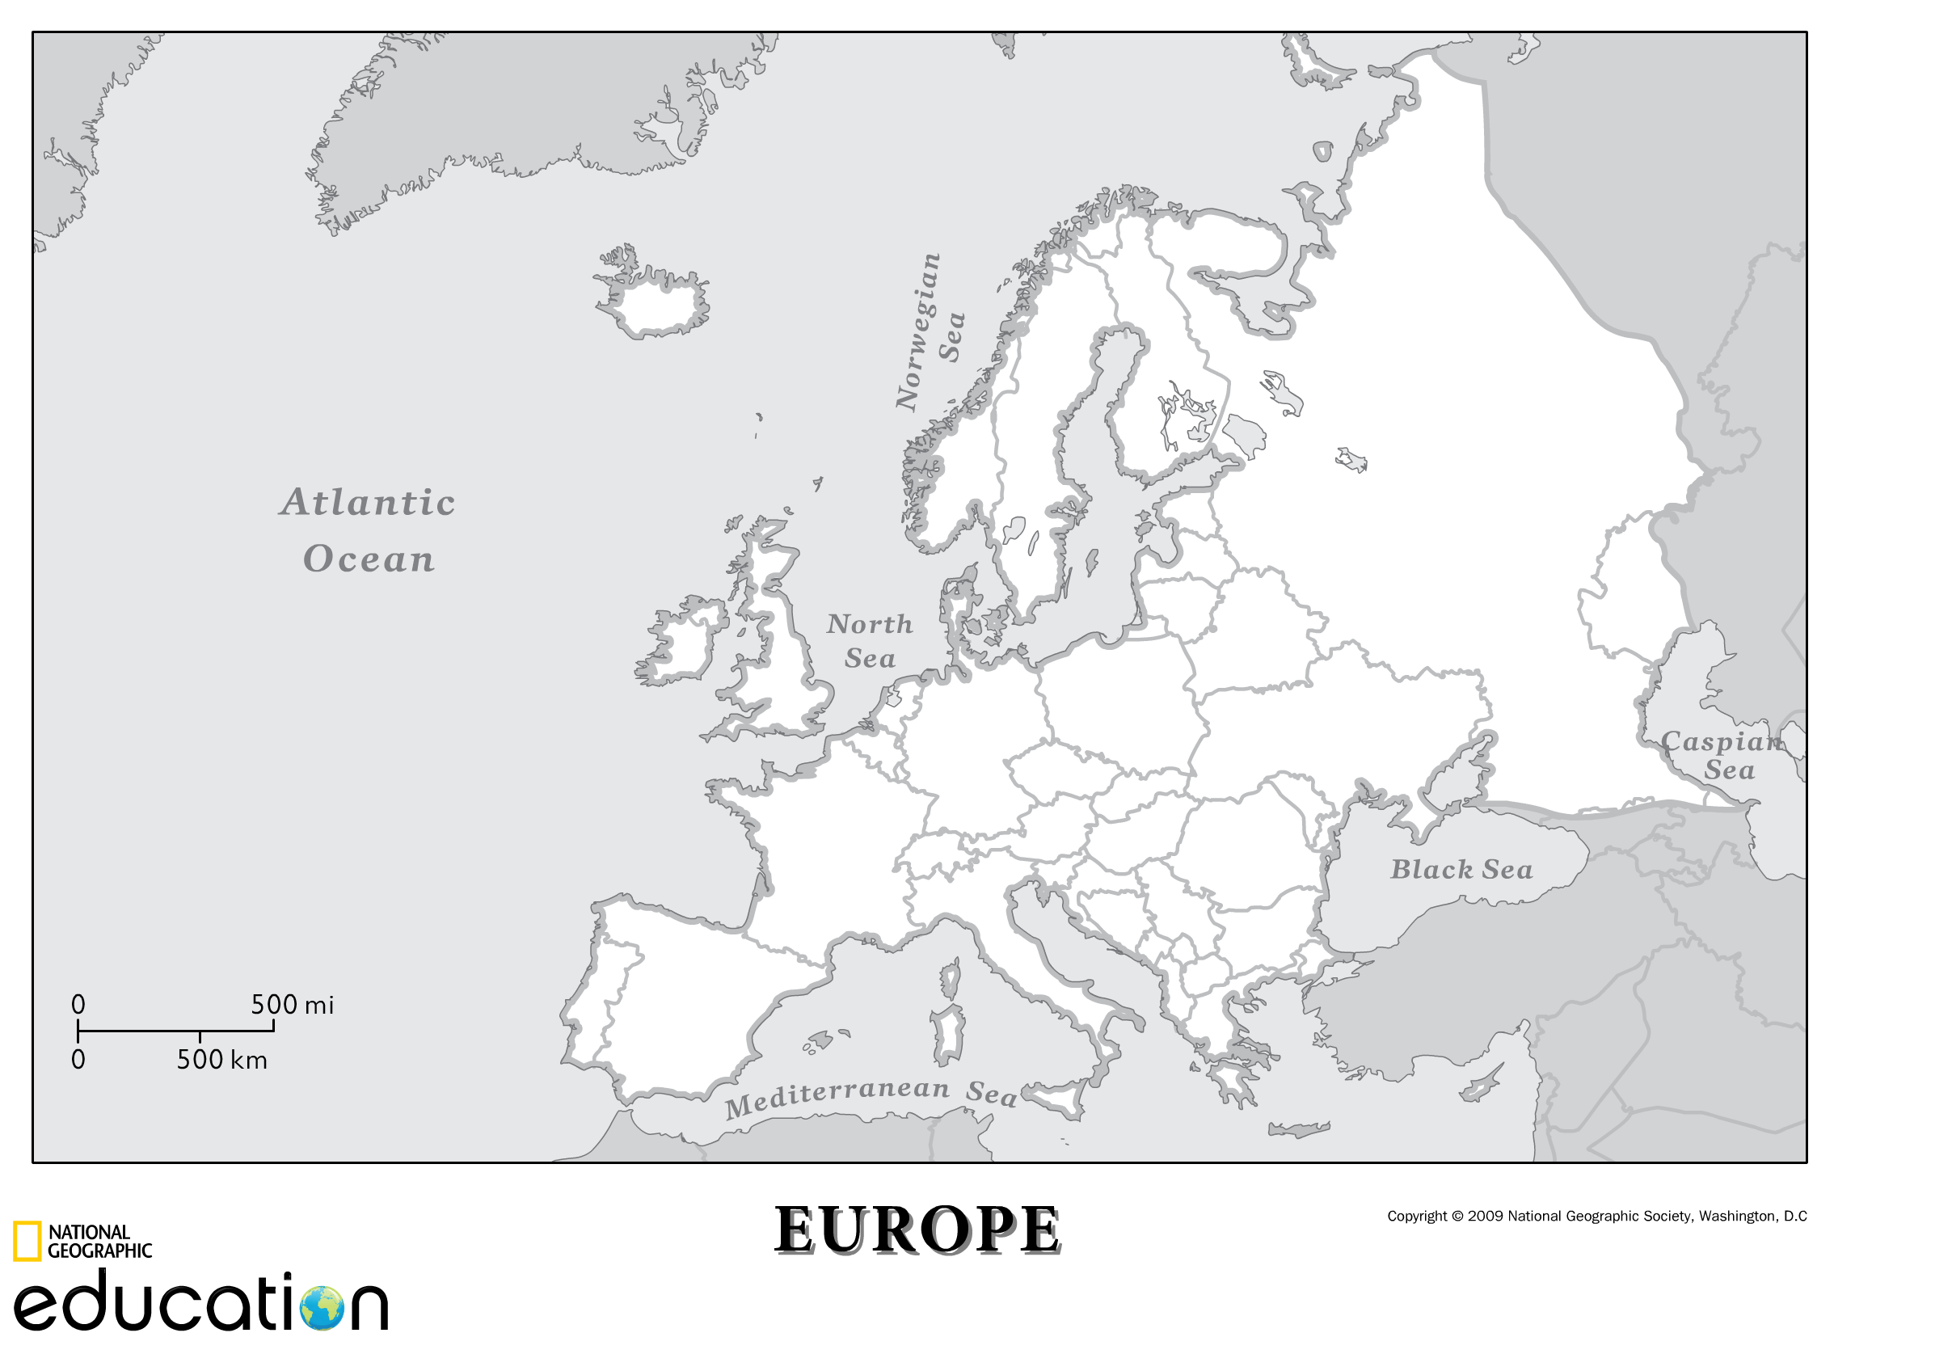

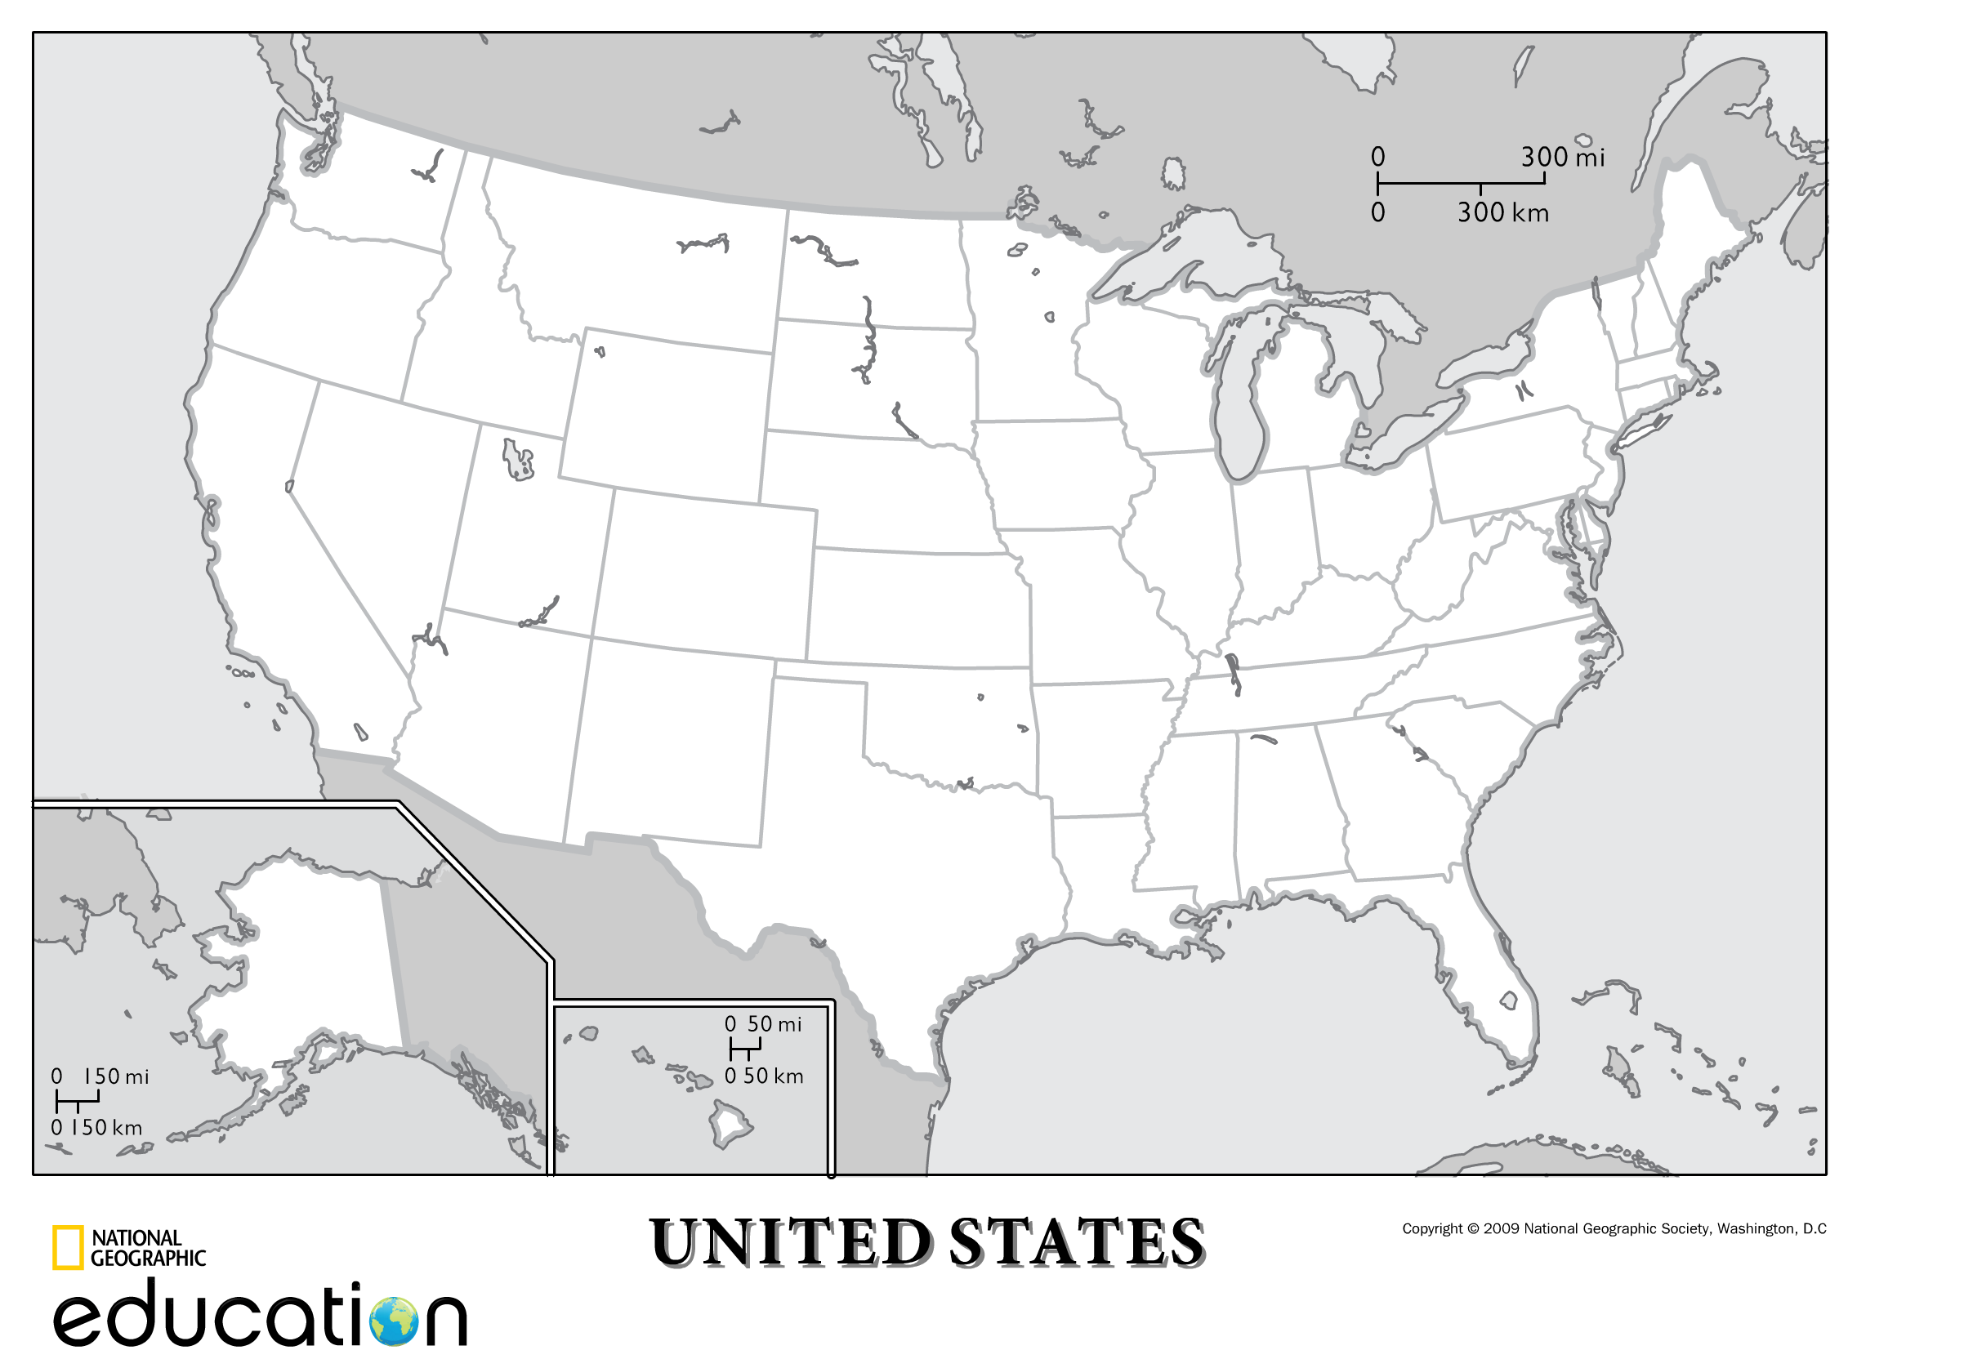

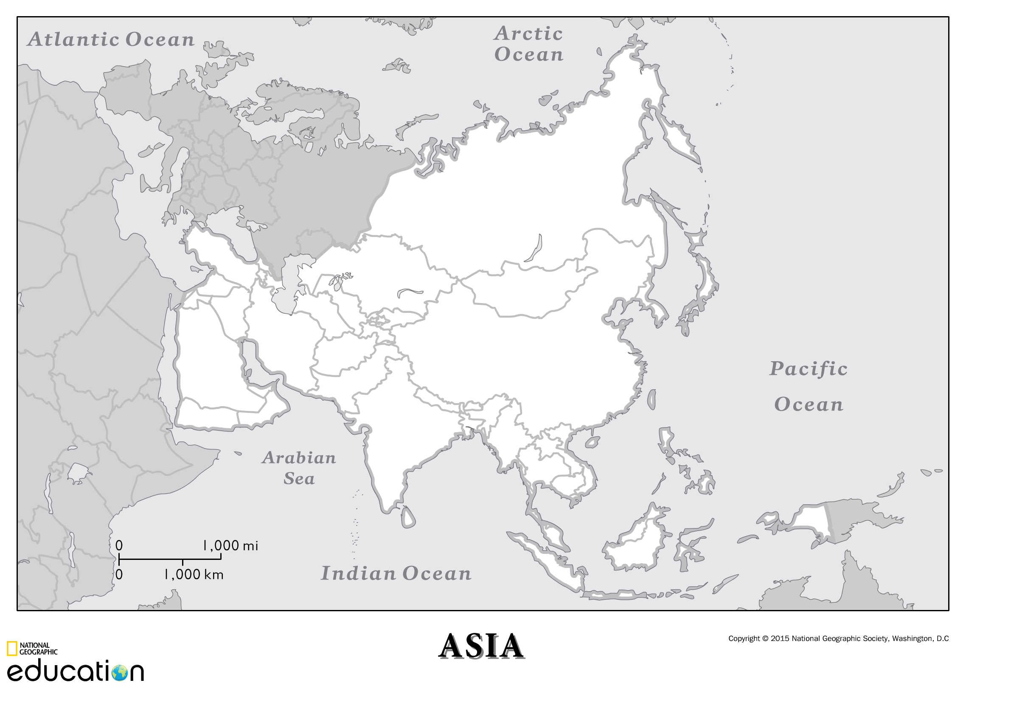

Chapter 11: Key Issue Three (Industry)
1. What areas of the world is coal found and why?
2. What areas of the world is petroleum found and why?
3. What about natural gas & why?
4. What are proven reserves?
5. What are potential reserves?
6. How much proven coal is there and where?
7. What about petroleum?
8. What about natural gas?
9. Compare the 3 graphs in Figure 11-40, what sims and diffs exist?
10. Identify where US natural gas fields are located using Figure 11:42.
11. What are oil sands?
12. Where are the largest oil sands found?
13. What is fracking?
14. Where is fracking taking place?
15. Explain the distribution of nuclear power in the world and in the US.
16. Explain the distribution of each of the following in the world AND its
impact: Uranium biomass wind Hydroelectricity geothermal Solar
17. Explain on a global scale pollution’s impact on climate change.
18. Explain on a global scale pollution’s impact on the ozone.
19. Explain the regional air pollution’s issues with acid rain.
20. Explain local pollution issues.
21. Why dos N Am have the highest demand for water?
22. Explain the impact of pollution on aquatic life.
23. What is the diff b/t point and non point source pollution?
24. What are examples of both?

Key Issue 4
25. What is outsourcing?
26. How does outsourcing impact location of industry?
27. Explain the placement of factories or maquiladoras in Mexico.
28. What are BRICs?
29. Explain how industry has shifted locations in N Am and why.
30 Explain how industry has shifted location in Europe and why.
31. Explain the diff in Fordist and Post Fordist production.

Ch. 12: Services Key Issue One
1. Services are what sector of the economy?
2. How much GDP is generated by services in MDCs?
3. What are the three types of services?
4. Explain each.
5. Use Fig 12-2 summarize the makeup of employment in the US in 75
words or more.

Key Issue Two
6. What is the single most important factor in profitability?
7. What is the central place?
8. Businesses in the CP do what?
9. The area around the CP is the what?
10. What shape is used to represent the market area?
11. Most consumers will go where for products?
12. How many regions exist in the US?
13. What meant by range?
14. Explain how range differs?
15. Most people don’t think in terms of miles but in what?
16. What is meant by threshold?
17. How is it determined?
18. What other factors are considered with the threshold?
19. Within an area there are large and small settlements—explain how this impacts range, threshold, & market area for both.
20. What is meant by rank size rule?
21. Explain how rank size rule works?
22. What is meant by primate city rule?
23. What is meant by the primate city?
24. Give an example of both RSR and PCR?
25. Explain how city ranking reflects a country’s development.
26. How is the concept of gravity applied to a market?
27. What two patterns are reflected in the model?
28. What is a periodic market?
29. Where is it usually found?
30. How are Periodic Markets important to the people?

Key Issue Three
31. Where are business services usually found?
32. What are global or world cities?
33. What makes a city a world city?
34. What 3 types of business services concentrate in world cities?
35. What are the other factors involved in ranking a city?
36. Explain what consumers & public services are in world cities
37. What two business services are found in LDCs?
38. What are offshore financial services/
39. What are the functions of BPOs?
40. What two reasons have lured business services to LDCs?
41. What are the two types of economic activities?
42. Explain each.
43. What is meant by economic base?
44. Explain how one business leads to another and another and so on.
45. What US cities have high numbers of scientists and professionals?
46. Name 10 cool cities.

Key Issue Four
47. What is meant by clustered rural pattern?
48. What is meant by dispersed rural pattern?
49. Explain and give examples of circular clustered rural settlements.
50 Do the same for linear.
51. Why are dispersed settlements found in the US?
52. Why the UK?
53. According to Wirth what are the 3 main characteristics of urban
areas?
54. Explain each of the three with details.
55. Explain how the world’s urban areas have changed and why in a min
of 100 words.
56. Explain how urban settlements size differ from MDC to LDC with
examples in a min of 102 words

